Coding Express STEM with LEGOS
and Code.org/Scratch
for students entering 1st-3rd grades

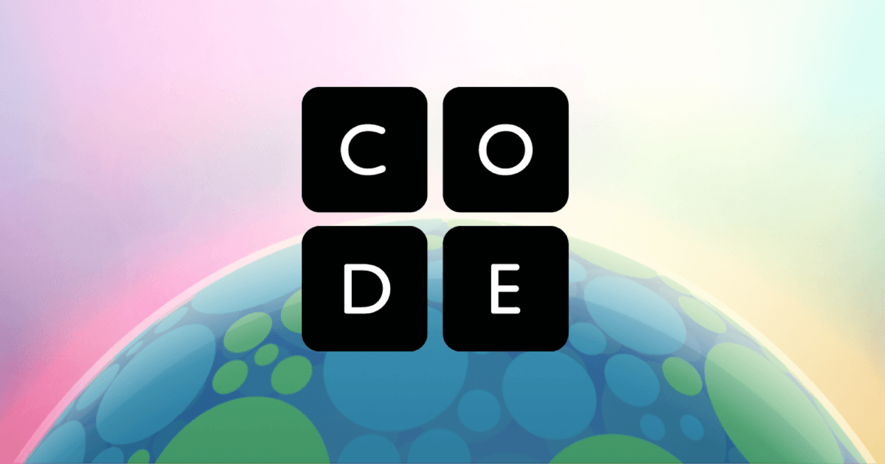
June 8th-12th
9am-12pm

Cost is $150.00 and includes a snack.

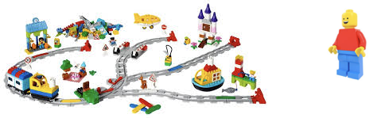

Mrs. Herring and Mrs. Young will inspire 1st-3rd grade learners to explore early coding concepts such as sequencing, looping, and conditional coding, while developing problem solving skills, critical thinking and collaboration.

————————————————————————————————————

***CCA student’s will be billed through FACTS ****

This camp is only open to students entering grades 1st-3rd and is limited to 14 students.

