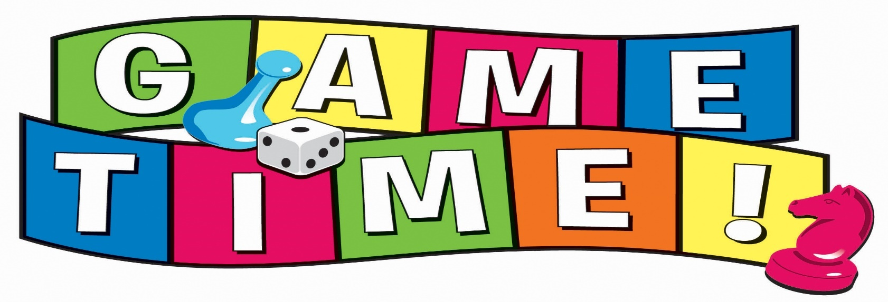
July 6th – July10th
9:00am to 12:00pm
Come joins us and have a week filled with fun and games!

- Water Games
- Large Group Games
- Cooperative Games
- High Activity Games
- Improvisation Games
- Rainy Day or Indoor Games
- Quick and Easy Games
- Nature Games
- Parachute Games
- Sports Oriented Games
- Tag Games
- Circle Games

Our camp will test critical and strategic thinking by teaching campers to play a variety of games, and to design their own game.

Campers will make friends, exercise their brains, and–most importantly–have fun!

Student’s entering 1st-5th grade Fee $160

