LEGO We Do 2.0 and Ozobots
for students going into grades 2nd-4th

June 8th-12th
1pm-4pm

Cost is $150.00 and includes a snack.

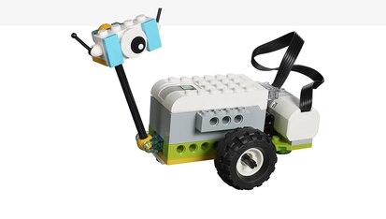
Mrs. Herring and Mrs. Young will inspire 2nd-4th grade learners to explore coding concepts such as sequencing, looping, and conditional coding, while developing problem solving skills, critical thinking and collaboration.

This camp is only open to students who are entering grades 2nd- 4th and is limited to 14 students.

****CCA student’s will be billed through FACTS ****

