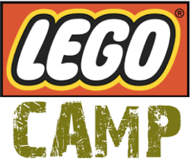

LEGO Camp
July 6th-10th
9:00am-12:00pm
Grades 1st-6th
Campers will experience hands-on activities with a variety of LEGOS as they collaborate on group structures as well as individual projects. This will feature something for both girls and boys. Camp will include a fun snack and each camper will bring home a LEGO creation at the end of the week. Put on your thinking caps and join us for an exciting week of creative building.
TEACHER: BRIAN WILBUR FEES: $190
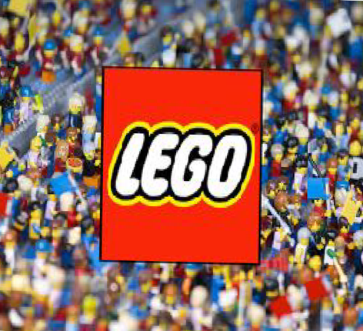
LIMITED TO THE FIRST 20 REGISTERED
****CCA student’s will be billed through FACTS ****

