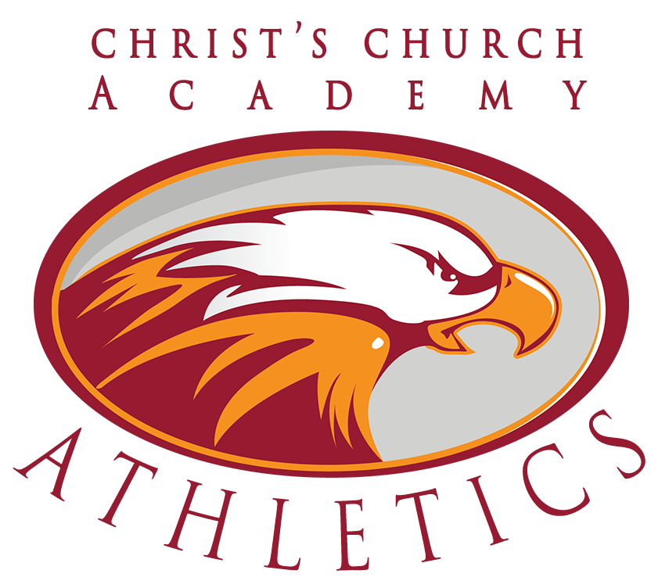

Building a Generation the World Will Not Change.

2021-2022
ATHLETIC HANDBOOK
Expectations for Student/Athletes

10850 Old St. Augustine Road
Jacksonville, Florida 32257
(904)268-8667
Dear Parents and Students,

Please review the contents of this handbook. Signing the permission slip is acknowledgement that you have read this handbook. We hope you will realize that the opportunity to participate at Christ’s Church Academy on one or more of our athletic teams is a privilege and not a right. CCA has adopted the following expectations in an attempt to support the students who participate in our program.

We are extremely proud of our athletic program and strive to prepare our student athletes for the next level by offering a strong counterpoint to collegiate athletic programs. While much of society believes that material gains are the reason that individuals participate in athletics, we hope that our students will understand there are far more important, intrinsic values that are associated with sports, such as camaraderie, self-discipline, teamwork and selflessness to name a few.

Our teams and coaches will respect their opponents and the game officials, and we expect them to be ambassadors of how things are done right in high school athletics. Please partner with us in the endeavor.

Sincerely,

CCA Athletics

Athletic Philosophy

The Athletic Program serves to reinforce Christ’s Church Academy’s philosophy that sound moral and spiritual values define the individual in a more significant way than academic achievement alone. The athletic programs provide an integral part of the school’s overall educational experience. Our purpose within the athletic programs is to build champions, but not just on the field. It is our desire to build champions in the community, in the classroom, at home and wherever God’s will takes our student athletes upon graduation. We believe that the commitment and discipline required to compete at the high school level will translate well as our students attend college, enter the workforce and start families. Lastly, we do believe that Christians are winners and should strive to win in all sports competitions. However, this does not mean that winning is everything, because it isn’t. Sometimes you learn more about yourself and your team when you lose than when you win. As Christians we are called to be leaders and set the tone for those around us, and we believe this holds true in athletic competition.

Athletic Fee

In order for student athletes to compete in sports, there is a fee per athlete, per sport ($200 for middle school, $225 for JV and varsity, and $250 for football). This fee must be paid no later than the student athlete’s first game. Student athletes cannot participate in a new sport if fees are not paid. Also, after competing in one athletic game, student athletes will not be refunded the athletic fee.

Athlete Physicals

In order to participate in athletics at CCA, students are REQUIRED to turn in a completed FHSAA sports physical, consent and liability waiver and concussion and heat related illness form (forms EL2, EL3), sports waiver, and a participation permission slip which are located on the school website under Forms and Permission Slips. All physicals must be up to date to participate in practice, competition and summer workouts.

Per FHSAA Bylaws, every student athlete is required to have medical accidental insurance to cover any sports related injuries. If it is not covered under your family insurance, you can now purchase a policy through CCA.

FHSAA Eligibility Regarding Participation in Sports

- A student not currently suspended from interscholastic or intra-scholastic extracurricular activities, or suspended or expelled from school is eligible to participate in interscholastic and intra-scholastic extracurricular activities.

- A student may not participate in a sport if the student participated in that same sport at another school during that school year, unless the student meets the criteria in Florida Statute s. 1006.15(3)(h):
- Children of active duty military whose move resulted from military orders.
- Children relocated due to foster care placement or McKinney-Vento Act.
- Children who move due to a court ordered change in custody due to separation, or serious illness or death of custodial parent.
- Good Cause:
- Move to a new residence following marriage of the student. The student immediately establishes a new residence that makes it necessary to attend a different school.
- Transfer of school within the first twenty days – i.e. acceptance into CCA after previously applying.
- Any athletic appeal which will require the Head of School, in conjunction with the guidelines set forth by the FHSAA, to intervene and make a decision on a case.

- A student’s eligibility to participate in any interscholastic or intra-scholastic extracurricular activity may not be affected by any alleged recruiting violation until final disposition of the allegation.

- Students who participate in interscholastic and intra-scholastic extracurricular activities for, but are not enrolled full-time in CCA, are subject to CCA’s code of student conduct for the limited purpose of establishing and maintaining the student’s eligibility to participate at CCA.

- The Florida High School Athletic Association (FHSAA) continues to retain jurisdiction over the following provisions: membership in the FHSAA; recruiting prohibitions and violations; student medical evaluations; investigations; and sanctions for coaches; school eligibility and forfeiture of contests; student concussions or head injuries; the sports medical advisory committee; and the general operational provisions of the FHSAA.

Orientations and Athletics

At the beginning of each season (Fall/Winter/Spring) each team will hold an information session for parents in order to provide essential information for the season. This meeting will include practice schedules, expectations, fees, and other important information.

Note: All fees will be due no later than the athletes first game. Failure to provide these funds will result in the student athlete being unable to participate in practices or games.

Recruiting

Both the school and FHSAA policy strictly forbid recruiting student athletes to CCA. Any act that is performed with the intent to entice, pressure or encourage students or parents to attend CCA is unacceptable. All student athletes interested in attending CCA should be directed to the CCA admissions office where they can obtain further information and begin the application process. All students admitted to CCA in Grades 6-12 will also need to have a completed FHSAA GA4 Affidavit of Compliance with the Policies on Athletic Recruiting & Non-Traditional Student Participation form on file.
Safety and Athletic Training

The CCA Athletic Department aims to provide a safe and enjoyable environment in which to participate. But it is critical to understand that participation in athletics involves inherent risk. Coaches and administrators will work in conjunction to ensure that they act in a prudent manner in order to prevent foreseeable accidents and injuries.

CCA is blessed to have the services of CORA Physical Therapy, Southeast Orthopedics, and St. Vincent’s Healthcare. Athletic trainers are here to assist with preventing injuries, as well as treating new injuries and post injury rehabilitation. In the event any student athlete has concerns or believe he/she may be injured or may be susceptible to injury, a conversation should occur with both the coach and one of our athletic trainers immediately so the proper actions can be taken.

Sportsmanship

CCA continues to cultivate a reputation of excellence and integrity in athletics. We want to be known for fielding competitive teams who are coached well and serve as examples and witnesses to others. Good sportsmanship is required on a daily basis. The CCA Athletic Department and CCA Administration expects our players, coaches and fans to behave in a responsible and courteous manner.

Any player or coach who is ejected from competition and/or behaves in a manner that results in the CCA Athletic Department receiving a fine, will not only be responsible for paying the required fine but may be subject to an extended suspension or punishment by CCA and the Administration beyond the suggested period of time set forth by FHSAA.

National Anthem Protocol

Out of respect for the anthem, country, and flag, the expectation is for CCA students and coaches to remove their hat and stand respectfully during the playing of the National Anthem. This expectation is in place when the student or coach is at an event representing CCA and/or at an event in which CCA team/group is performing. CCA believes the time during which the National Anthem is played is a time of respect for those men and women who have given their lives while representing our country as well as those men and women who currently risk their lives daily in defense of our country.
Should there be a student or coach who feels they have a reason not to comply with this expectation they are asked to meet with the Head of School to discuss their thoughts. A student or coach who does not meet with the Head of School and does not stand respectfully for the National Anthem could face disciplinary action. It is important to know that our focus is on the students and coaches of Christ’s Church Academy. We will not attempt to regulate the behavior of others.

Team Selection and Participation

Tryouts will be conducted at the beginning of each sports season with the understanding that coaches may be required or choose to limit the number of players on any given team. Our philosophy on team selection and competition at the various interscholastic levels is as such:

Varsity:

- CCA is committed to fielding the best possible varsity team
- Selection is earned based on skill and maturity
- Playing time is determined by the coaching staff

Junior Varsity:

- Junior varsity will be the transitional level between middle school and varsity.
- Junior varsity teams will be compromised of players from 6th – 12th grades
- Coaches will make every effort to ensure playing time; however, it is not guaranteed.

Middle School

- Middle school teams are comprised of 6th – 8th grade students
- Middle school teams are considered introductory level teams and every effort will be made to include all who wish to participate. However, certain middle school teams will have cuts to ensure legal roster sizes.
- Middle school teams are members of JCAL (Jacksonville Christian Athletic League) with tournaments at the end of each season.

Students are NOT required to take part in athletics as a requirement for graduation. Students are encouraged to participate in more than one sport, but will not be permitted to participate in two sports during the same sports season (i.e. Fall, Winter, Spring).

Varsity First Approach

CCA Athletics believes that building from the bottom up is critical to growing our programs. Effective management from the top down will aid this process along and provide varsity coaches with better-prepared athletes. As a small school it is imperative that our varsity programs develop success first to inspire the younger
generation of athletes at CCA. Therefore, those sports, which have lower numbers of athletes, will hold tryouts for the varsity team first, and upon varsity selection, the coaching staff and CCA Athletic director will determine whether there are sufficient numbers remaining to field a middle school team.

Academic Eligibility

- CCA will follow the eligibility standards set forth by the FHSAA. Grades will be checked at the culmination of each semester. A cumulative GPA of 2.0 must be maintained to stay eligible for athletics.

Attendance

- Student athletes are expected to attend all classes without being tardy
- Coaches must be notified prior to practice if a student is unable to attend.
- Players are expected to attend ALL practices. A missed practice may result in missing a game or reduced playing time. If sick or injured, students are still expected to attend practice and watch and encourage teammates. You may not, however, attend practice if you are currently suspended.
Note: Rehabilitation of sports medicine injuries will count as practice.
- Students who sign in unexcused after first period will NOT be able to participate in practices or competitions

Cancellation of Games and Practices

- Cancellation of games or practices will typically be announced before the end of the school day. More information about game cancellation can always be obtained by calling the Athletic Department at 904-268-8667 x 131.
- Student athletes should always come to school prepared for practice regardless of current or forecasted weather conditions.
- Cancellation of games is determined by the home team.

Communication

- Coaches should always be contacted first regarding issues that have to do with their team. If issues are unable to be addressed at this level, players and/or parents should contact the Athletic Director.

Equipment and Facilities

- Do not alter any equipment issued to you.
- Care for all equipment that is provided to you.
- You are responsible for locking and securing all valuables. The school will not be responsible for lost or stolen items.
- All school equipment and uniforms issued to you will be returned to the coach or athletic department within 5 school days of your last contest. Failure to do so will result in disciplinary action and may result in grades/ transcripts being held.
Note: Families will be billed for equipment lost.

Lettering

To letter for a CCA varsity team, an individual must meet one of the following requirements, as determined by the coach and athletic department:
- Participate in a reasonable percentage of the games played. JV players moved up to varsity after the completion of their season are not eligible to letter for that varsity team
- Bring value to the team in some form
Note: Only sophomores, juniors and seniors may order letter jackets.
- Players receive a letter once (regardless of number of sports played) and then a pin in subsequent years

Non-school participation

- School sponsored athletics will take precedence over non-school athletic activities.

Quitting

- If any student athlete quits during a sport season, he/she will not be allowed to play during the next sport season (i.e. if a student quits a fall sport, the student must sit out for winter sports). *Any exceptions to this will be left to administrative discretion.
- The coaching staff reserves the right to deny any student athlete that quits a team the right to tryout the following year
- Being expelled from school will have the same result as quitting. All honors and awards will be denied

Respect

- Players can expect to be treated with respect by their coaches
- Players will always exhibit respect to all teammate, coaches, teachers, school personnel, and to officials
- Public displays of affection between students in the school setting or at an athletic event is against school policy
- Failure to adhere to the above will result in some form of disciplinary measure

The Athlete

- Treats opponents with respect
- Plays hard
- Maintains self-control at all times
- Respects officials and their calls without argument
- Wins without boasting, loses without excuses and does not, under any circumstances, quit.
- Always leaves host school facilities better than when they found them
- Remembers that it is a privilege to represent the school and the community
- Responsible for getting all assignments from teachers on early dismissal competition days, and then make up and submit the work missed the next day.

The Coach

- Treats players and opponents with respect
- Inspires athletes to appreciate and love the game
- Leads by example
- Disciplines poor behavior
- Respects officials

The Fans

- Understand that they represent the school just as the players do and therefore must display good sportsmanship
- Show compassion for injured players
- Do not distract players before or during competition
- Treat opponents and officials with respect
- Respect the property of our school, as well as any host schools
- Behave modest in victory and gracious in defeat

Transportation

- All student athletes must ride with the team on school provided transportation, unless otherwise specified by the school.
- Exceptions include: Parent permission using CCA’s driving waiver - OR- a written request in advance to the athletic department, which must be confirmed prior to approval.
- Athletes and coaches are expected to treat buses and bus drivers with respect, and clean the bus upon completion of the trip.

On the website you will find the following forms, all of which must be turned in prior to your student athlete participating in CCA Athletics.

- EL-2 FHSAA Physical (3 pages)

- EL-3 FHSAA Consent and Release of Liability Certificate (4 pages)

- CCA Athletic Permission Slip (which also serves as acknowledgement of the CCA athletic handbook)

- Sports Waiver

